Reflections
The Reflections Program is a National PTA and Georgia PTA cultural arts competition. Since 1969, over 10 million students across the nation have taken part in this popular PTA program.
The purpose of this program is to provide an opportunity for students to use their creative talents by expressing themselves through their own original works. The excitement and enthusiasm that the program generates for students, parents, schools and communities is unmatched with the majority of Georgia PTAs participating in the program at all PTA levels.
Young artists get involved through their local PTA or PTSA. A student may submit an entry in any of six arts areas. Only original works of art are accepted. The six art areas are: Visual Arts Photography, Literature, Music Composition, Dance Choreography, and Film Production.
That's why the Reflections Program provides an excellent opportunity for students of all ages to:
- Unleash their creative talents and be inspired
- Express themselves imaginatively in their artwork
- Experience the joy and fun of making art
- Tap into critical thinking skills to create art inspired by the annual theme
- Receive positive recognition for their original works of art
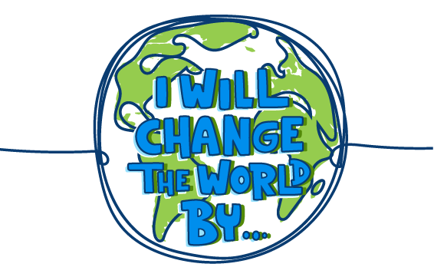
The 2021-2022 Reflections Theme is: I Will Change The World By...
Rules and Entry forms:
https://www.georgiapta.org/reflections/reflections-submission-info#80-rules-and-forms

